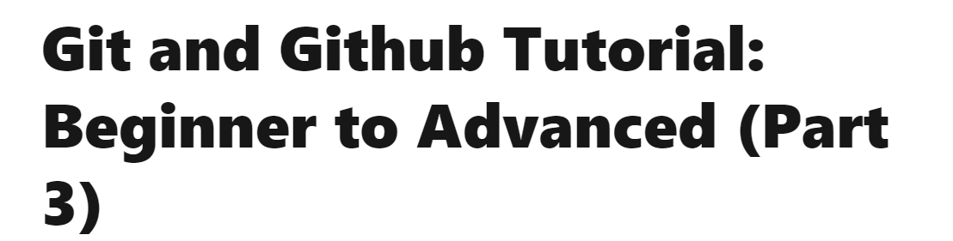

Git Installation

* [https://git-scm.com/downloads](https://git-scm.com/downloads%20%20)  - Download GitSCM - Download command line not the GUI One
* EXE will be downloaded , once downloaded install it by clicking next next.
* Open DOS command Prompt by typing “CMD” in search bar. Command prompt will open.
* Go to the Git directory C:\Users\KIRAN>cd C:\Program Files\Git
* 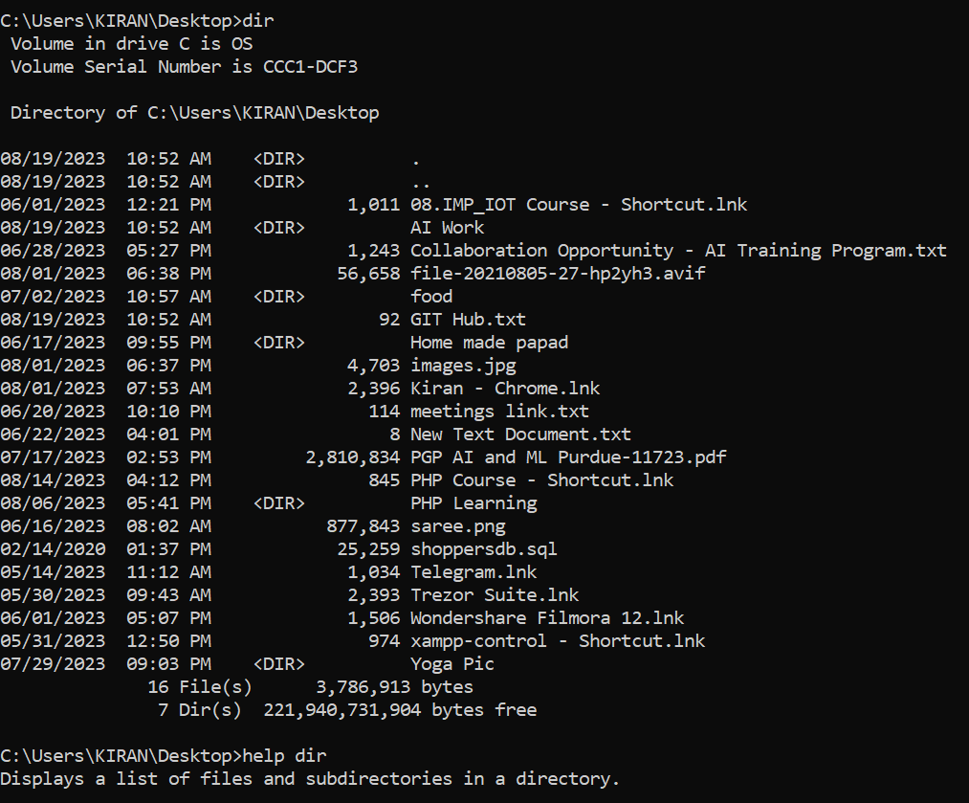
* If you get above commands that’s means git is Installed
* Open C:\Program Files\Git

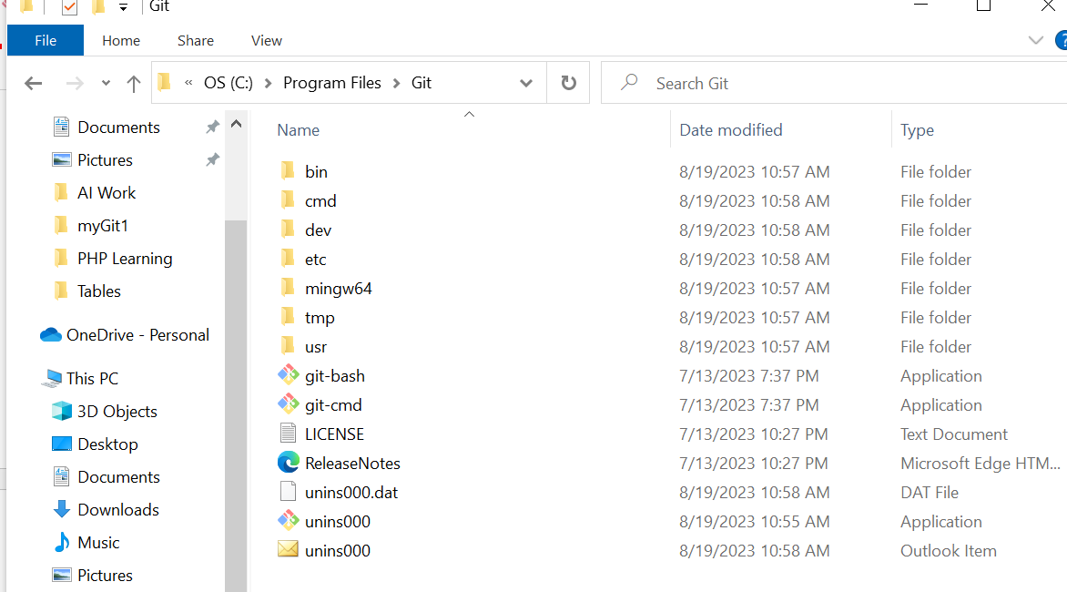

* Double click on git-cmd
* C:\Program Files\Git>git

